MODULE CODE
CSE202

TITLE OF PAPER
OBJECT ORIENTED ANALYSIS AND DESIGN WITH JAVA

STUDENT NAME
PEARL GAOPATWE

CSE24-056
STUDENT NUMBER

Part A
1.Requirements Elicitation
- Customer registration-The systems allow new customers to be registered with customer details.
- User authentication-Customers must log in with valid credentials to access their accounts.
- Open account-the system allow customer to open different types of accounts,savings,investment and cheque accounts.Investment requires minimum of P500.
- Data persistence-Customer ,account and transaction data must be stored permanently.NON-FUNCTIONAL REQUIREMENTS
- Security-Enforces role base access control.
- Performance-Typical account queries must respond within 200ms under normal load.
- Data integrity-The system must be consistent, so balances never diverge due partial failures.
- Auditability and logging-All critical operations must be logged with timestamp, actor and details.
2.STRUCTURAL UML MODELLING
System Usecase diagram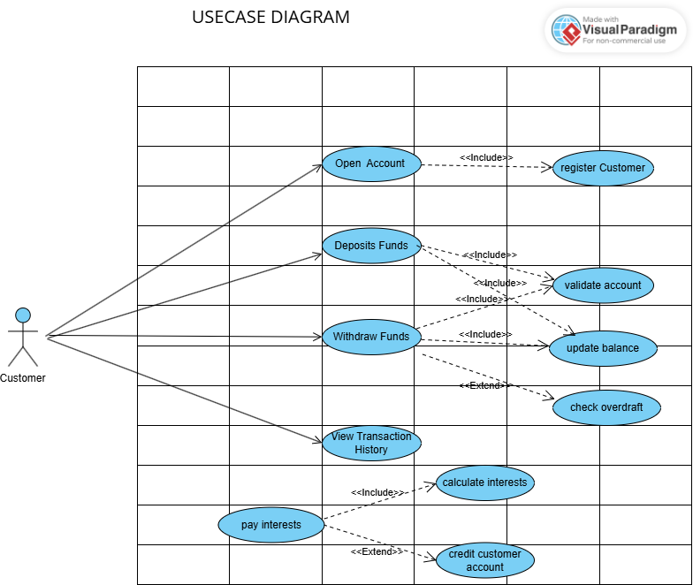

Class Diagram
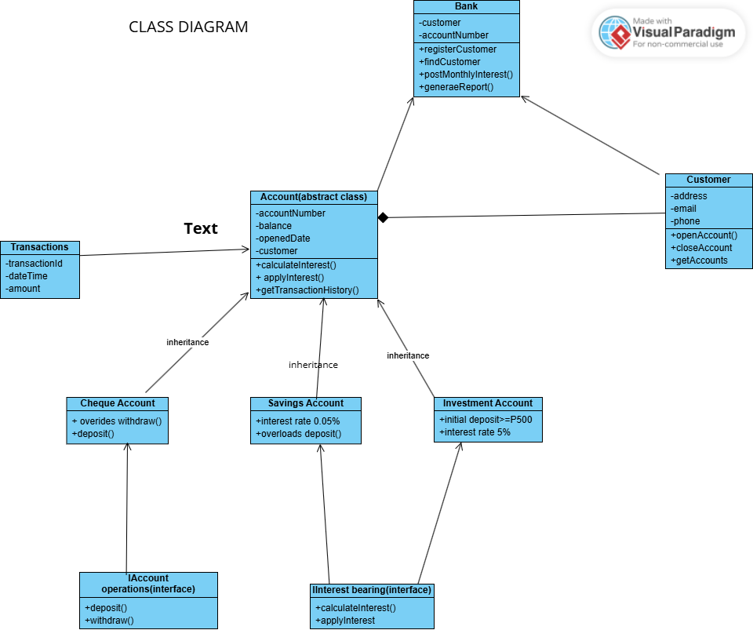

3.BEHAVIOURAL UML MODELLING
WITHDRAW SEQUENCE DIAGRAM
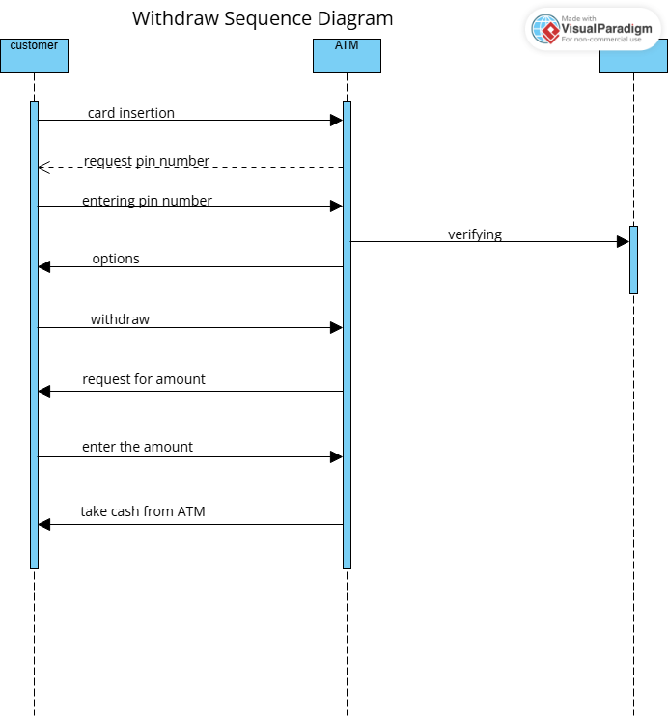
DEPOSIT SEQUENCE DIAGRAM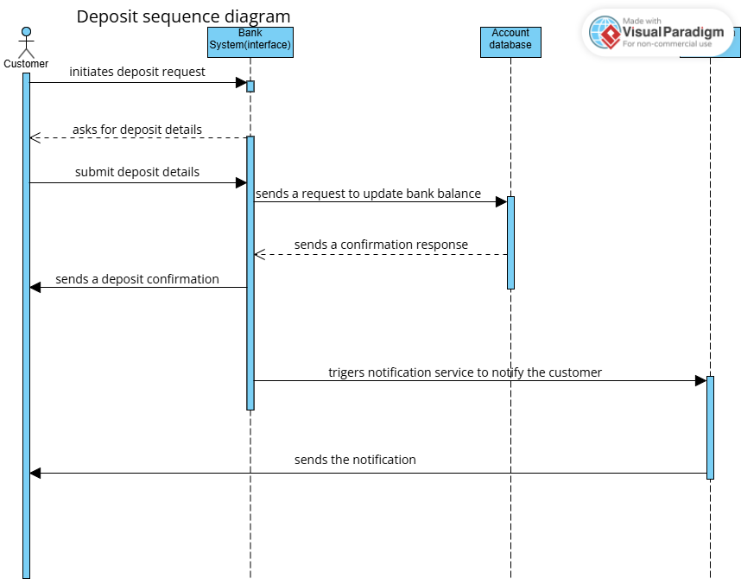
STATE DIAGRAM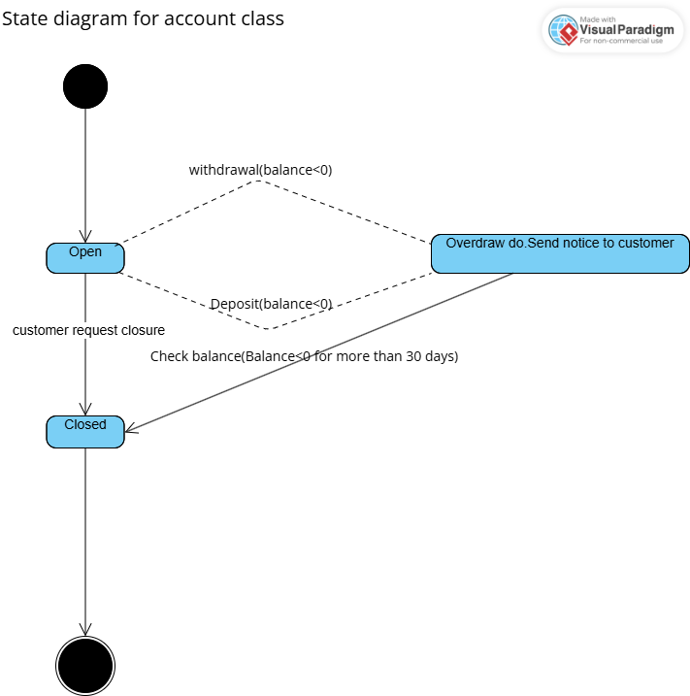

MOCK INTERVIEW (INTERVIEW RECORD)
On the 18th of September at 10:00 hrs an interview was conducted on
FUCTIONAL REQUIREMENTS of a bank system. Interviwer:Student
Respondent: Lecturer

Interviewer: What account types should the system support and what are their rules?
Respondent: Savings account, only deposits are done here with monthly interests for individuals at 0.025% and companies’ monthly interest at 0.075%.
Investment account, support both deposit and withdrawal, minimal
deposit of P500 at 5% monthly interest.
Cheque account, support both deposit and withdrawal and used for
Employed customers to grant salaries.
Interviewer:Can a customer hold multiple accounts.
Respondent:Yes,a customer can have all three accounts the cheque, investment and savings accounts at one time.

Interviewer: Are there approval steps for opening account.
Respondent: Automated opening is acceptable.

